
NOTE: This is an official document by Indexademics. Unless otherwise stated, this document may not be accredited to individuals or groups other than the club IDX, nor should this document be distributed, sold, or modified for personal use in any way.
IDX G9 Physics S STUDY GUIDE ISSUE 8
By Joyce and Virginia, Edited by Isabella

Part 1 Momentum and Impulse

- Momentum

Definition:
- Momentum (p) is the product of an object's mass (m) and its velocity (v).
- Units: kg·m/s
- Vector Quantity: Direction is the same as the velocity.

Key Points:
- A truck and a roller skate can have the same momentum if the skate has a much higher velocity.
- Momentum depends on both mass and velocity.
- Mass and velocity control collisions.

Momentum Changes:
- If velocity doubles, momentum doubles.
- If mass doubles, momentum doubles.
- If both mass and velocity double, momentum quadruples.

- Impulse (I)

Definition:
- Impulse is the product of force (F) and the time (Δt) over which it acts.
- Units: N·s
- Vector Quantity: Direction is the same as the force.
- Graphical Representation: The area under a Force vs. Time graph equals impulse.

Impulse-Momentum Theorem:
Means that delta p = I

Key Points:
- Large Δt ⇒ Small F (e.g., airbags increase collision time to reduce force).
- Small Δt ⇒ Large F (e.g., hitting a concrete wall stops a car quickly, exerting a huge force).

3. Applications and Problem-Solving Tips
(1) Collisions: Objects with different masses experience the “same force” during collision (Newton’s 3rd Law), but their “momentum changes” depend on mass and velocity.

(2) Graphical Analysis:
(F-t graph)
- Positive area: Impulse in + direction.
- Negative area: Impulse in - direction.

Key equation final review

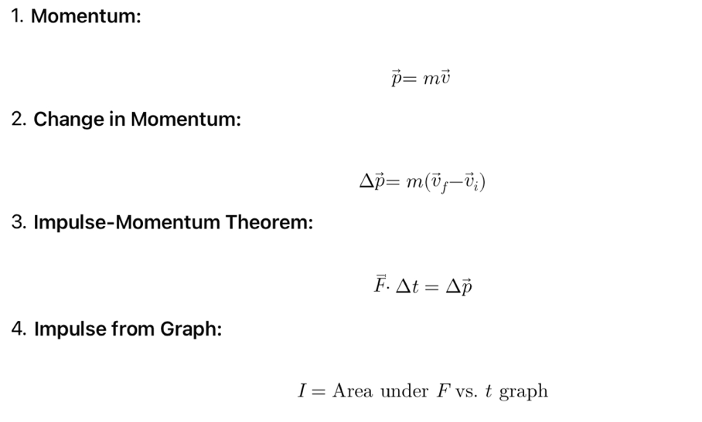

Important

- Momentum is conserved in isolated systems (no external forces).
- Impulse explains how forces affect motion over time.
- Practice: Solve problems with varying mass, velocity, and force to master these concepts.

Part 2: Conversation of Momentum

- Definition
Law of Conservation of Momentum: The momentum of any closed, isolated system does not change.
- Closed system: A system that does not gain or lose mass
- Isolated system: A system where the net external force on a closed system is zero

Important
-The sum of the momenta of the balls is the same before and after the collision in a closed and isolated system

Formula:
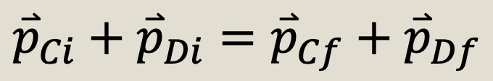

- Recoil
